**Finals Task 3. Using MYSQL Clause**

**Instructions:**

1. Create a database named online_courseDB
2. Use the online_courseDB
3. Copy and paste the initial query then perform the SELECT statements required for each problems in the figure below: (download onlineCourse.sql file)

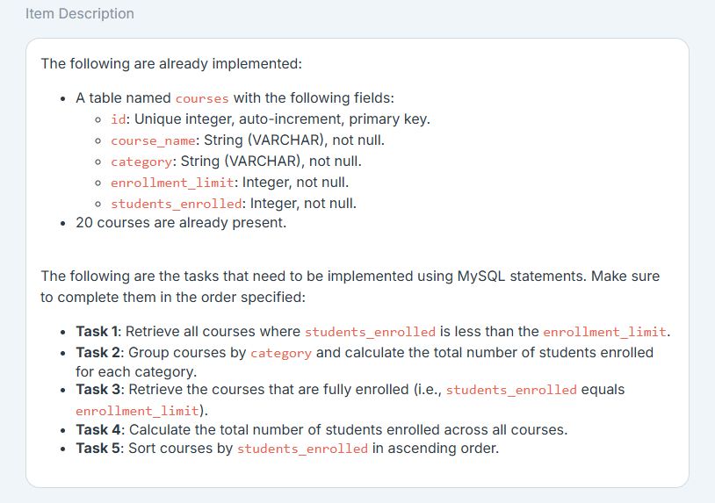

**Required Outputs to be posted in your Github portfolio**

1. Query statements (Task 1-5)

2. Output of each query (Task 1-5)

4. SQL copy of the database and table structures